# **Dear New Grad**

### Some tips to get you started.

Zoe's avatar

[Zoe](https://substack.com/@zoeffc)

May 16, 2025

3

[1](https://femmefuturescooperative.substack.com/p/dear-new-grad/comments)

1

Share

Hello!

It’s college graduation season! I know I have some grads in the Femme Futures Cooperative and I hope you had a fantastic celebration with your people.

My goal today is to provide a handful of honest tips on navigating life immediately post-grad. TLDR: it isn’t for the faint of heart but it also isn’t optional. You must do it, and I believe that you can do it with flair and finesse.

*If you are NOT a new graduate, add your tips and thoughts in the comments! And I hope that this is a bit of a trip down memory lane.*

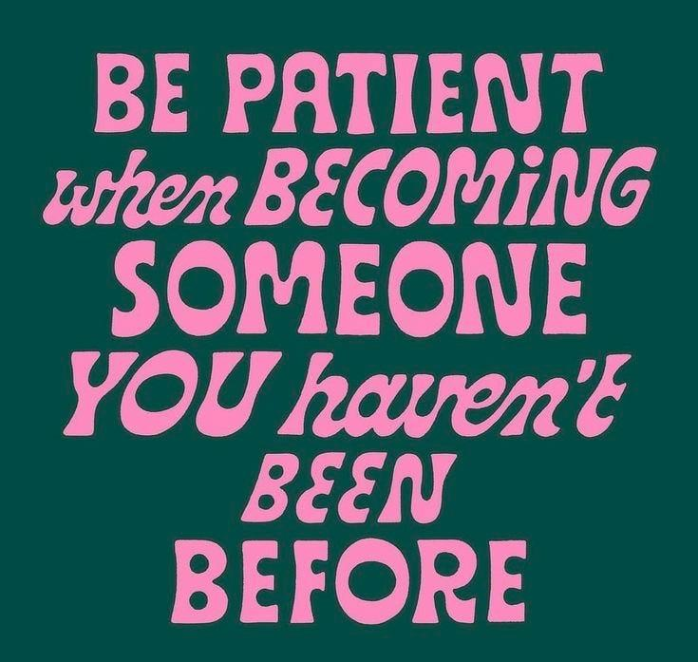

Before I go any further — let’s do the housekeeping.

First, if you are not already a subscriber and you resonate with any of the following descriptors, consider joining the cooperative: (1) Early-career professional; (2) Feminist; (3) Do-gooder; (4) Former Gifted Kid; (5) Overachiever; or (6) Capitalism-hater.

Subscribed

Second, if you like what I am saying and it makes you think of someone in your family/office/friend group, send it their way.

[Share Femme Futures Cooperative](https://femmefuturescooperative.substack.com/?utm_source=substack&utm_medium=email&utm_content=share&action=share)

Third, I say some personal and vulnerable shit every week. Say some vulnerable shit back. It’s called a community.

[Leave a comment](https://femmefuturescooperative.substack.com/p/dear-new-grad/comments)

Okay — back to it.

1. **You are going to feel behind.** You will feel like your peers are lapping you and you are in one of those bad dreams where you are trying to run but just cannot make your feet go. Here are a couple things to remember: (1) you are adjusting to a new time scale, adulthood is long and the three, six, twelve months it might take you to get a job *are* painful, but ultimately, not more than a drop in the bucket; (2) there is always going to be someone moving faster than you and there will always be someone moving slower than you.
2. **As someone who got a big girl job out of college, I am here to report that the grass is still greener on the other side.** Don’t get me wrong, I am grateful and proud of my career path, but recently, I have found myself spiraling about not making the most of my twenties. I would not recommend joining the corporate workforce before you are 25 years old (not being taken seriously is so much worse than I expected it to be). All of that being said, I know that when I was graduating from my fancy school with my fancy degree, I felt like I absolutely needed to land a 9-5 in order for it all to have been worth it. The moral of the story is that whatever path you end up going down, you will have regrets, but that does not mean that you would have been better off going down the other path.
3. **Build authentic networks.** Looking for a job feels like an impossible task when you don’t actually know any working people. Networks are important. Unfortunately, real networks take time to create. I am not saying not to reach out to anyone in your field to ask for a coffee or a 15-minute ZOOM call — that got me to my first job — but I am saying that once you launch, the majority of those people will fade into your periphery, and that is okay. You can make friends in your field once you are in it. That is your network. [[Here’s a note I wrote about those a while ago!](https://open.substack.com/pub/femmefuturescooperative/p/talk-networks?r=3833jd&utm_campaign=post&utm_medium=web&showWelcomeOnShare=false)]
4. **Get in touch with your body and with your mind.** This advice is good for anyone at any point in their life, but it is something that I wish I had figured out by the time I was in my first job. Get active to the point that you know what your body feels like on a good day and what it feels like on a bad day. Pay attention to what stress feels like in your body, but also what joy, and focus feel like. When you know those things, you are better able to look out for yourself and to carve the right path forward. Knowing your mind, on the other hand will allow you to have a safe space to come home to in turbulent times. You will need to navigate challenges and you are naturally going to react to those things. I am all for feeling things, but I at the end of the day, you need to be in charge of your mind more than your external circumstances are.

Good luck on your next chapter. You’ve got this!

Best,

Zoe

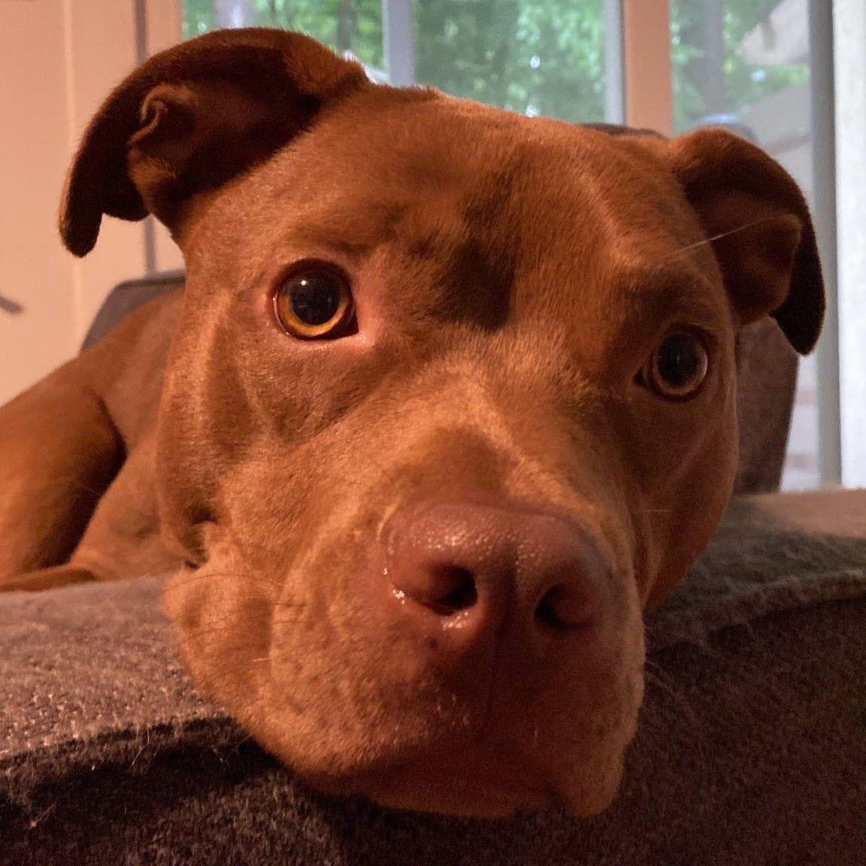

P.S. It was Mia’s first birthday this week!